Life in the Paleolithic Era
Our earliest ancestors roamed around in search of food, spreading all over the globe.
animals | caves | fire | hunter-gatherers
migrated | nomadic | Paleolithic | permanent
plants | skin | stone | wandered
The word ___________ means the Old Stone Age. Early humans living in the Paleolithic era ___________ around in search of food. They lived in small bands, hunting ___________ and gathering wild ___________, berries, and nuts for food. We call people who lived like this ___________.
People in the Paleolithic era did not have ___________ houses. They lived a ___________ life following animals that ___________ from place to place. They lived in ___________ or made temporary
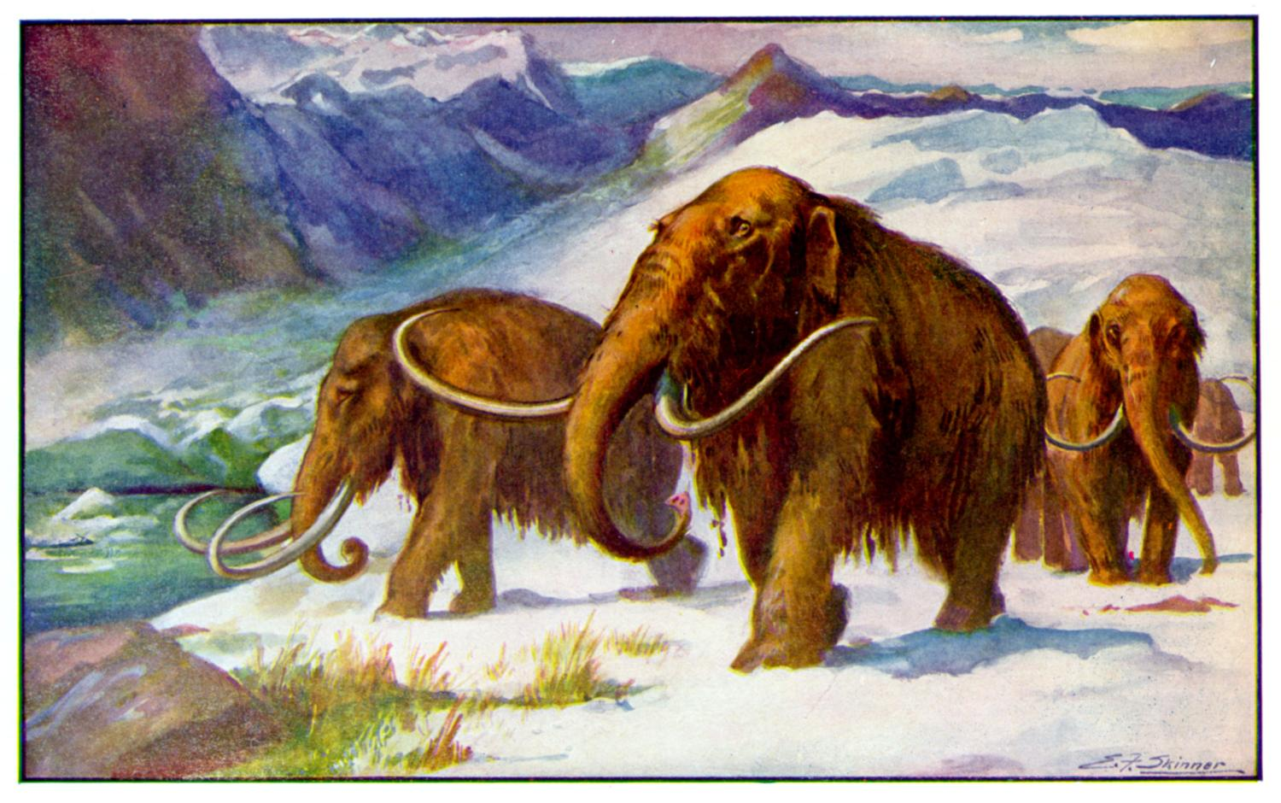 | shelters out of wood, bones, and animal __________. They made tools out of ___________, wood, and bones as well. Their ability to make tools helped early humans to thrive and
spread across the four corners of the earth. They were also helped by their ability to use language for communication as well as __________ to keep warm and cook.

