The Phoenicians Crossword
Across
2. A settlement that is separate but under control of the home country.
6. The sea where Phoenicians traded.
8. Exchange goods between people.
10. Name of the purple Phoenician dye.
11. A system of writing where one letter represents one sound.
12. A seafaring trading people in the Mediterranean.
14. Trading goods for goods without exchanging money.

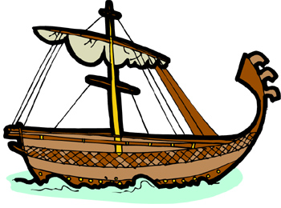
Down  1. Finding your way across an ocean.  2. Money made from metal.  3. The area where Phoenicians lived.  4. People use this color their clothes.  5. A person who writes. | 7. A successful trading colony of Phoenicia in the western Mediterranean.  9. The star that Phoenicians used to navigate at night with.  12. A city next to the sea.  13. A type of tree commonly traded by Phoenicians.

