The Great Mortality: The Plague in Europe
Black | buboes |  | bubonic | Flagellants
fleas | Jewish |  | pandemic | population
rats | Scandinavia |  | Sicily | wages
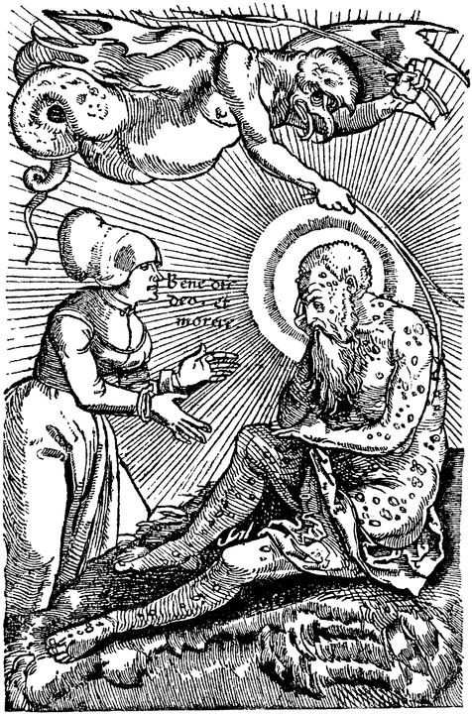  A woodcut depicting a man infected with plague and buboes under his skin. |  | In 1347, a great calamity known as the __________ Death struck Europe. This plague was brought to Europe by galleys coming back from the Crimea to __________. From Sicily, the plague spread north into Europe and by 1350, it had spread as far north as __________.  The plague was spread by __________ who lived in the fur of __________ and other
rodents. It caused swollen bumps, called __________, on people’s skin that oozed puss and blood when cut open. And so, the plague is often called the __________ plague. The plague was __________, meaning it was widespread over many regions. By the time the plague died out, between one-third and two-thirds of the __________ of Europe had been decimated.
The plague had a great effect on European society. Some groups saw the plague as punishment for their sins and began whipping or beating themselves. These people were called __________. Other Europeans began attacking __________ communities who they accused of poisoning the wells. Some people, such as workers, even benefited from the plague as they could ask for higher __________ since the drastic decrease in population meant there was a huge shortage of labor.

