The Black Death Crossword

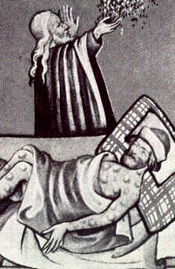
A depiction of a plague victim.
Across  2 Diseases ___________ from person to person. (6)  3 A rapidly spreading disease within a region or city. (8)  5 The plague is often called the _______ Death. (5)  6 An insect on rats that carried the plague. (4)  7 The sudden appearance of a disease in a community. (8)  9 The number of people in an area. (10)  11 Small single cell organisms responsible for causing the plague. (8)  12 To give somebody a disease. (6) | Down  1 A disease that is widespread across many regions or continents. (8)  4 To keep people with a disease separated from the rest of society. (10)  5 A swelling of lymph nodes under the skin due to plague. (4)  6 A person who whips or beats him or herself as penance. (10)  8 Type of plague that causes buboes to form under the skin. (7)  10 An animal that often carried fleas that spread plague. (3)

