Medieval Society
clergy | fight |  | fields | god
horses | knights |  | manors | military
peasants | poorest |  | pray | work
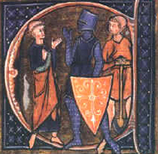  A monk, a knight, and a peasant representing the three orders. |  | During the middle ages, people in Europe saw society as being divided into three orders: those who __________, those who __________, and those who __________.
The people who worked were the __________. They were the __________ group in society and were often illiterate. Typically, peasants lived on estates called __________ and worked the fields. They spent part of the time working in their own __________ and part of the time working in the fields of the lord of the manor.
The people who fought were the __________ who came from the class of nobility. They did not work in the fields, but instead were expected to perform __________ obligations to their lords. Becoming a knight was expensive because knights were expected to provide their own __________ and weapons. Therefore, only nobles could become knights.
The people who prayed were the __________, which included the priests, the monks, and the bishops. They were considered the highest order in society since they were thought to be the closest to __________.

