The Mayas Crossword
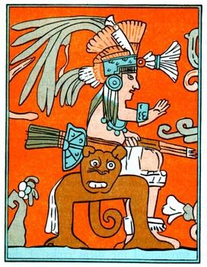
Across
2. A thing that tells the days of a year.
5. Killing something (or someone) for the gods.
6. A delicious drink made from cacao beans.
10. Deep natural wells that the Mayas used for water.
12. A Mayan book that tells the myths of the gods.
14. Exchanging goods between regions.
15. A word meaning middle America.
16. Valuable green stone used in art.
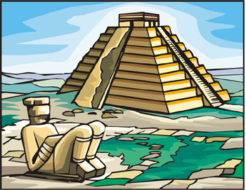
Down  1. Part of a human that Mayan priests cut out for human sacrifices.  3. A large Mayan city with six tall stone temples.  4. The Mayan math system had this number which stands for nothing. | 7. A building used to watch the stars and planets.  8. King from the city of Palenque.  9. A picture symbol used for writing.  11. A sharp black glassy rock.  13. The shape of many Mayan temples.

