Mayan Civilization
The classical period of Mayan civilization lasted from around 250 A.D. to 900 A.D.
architects |  | astronomy | calendar | glyphs
Mesoamerica |  | observed | obsidian | paper
pyramids |  | Tikal | trade | zero
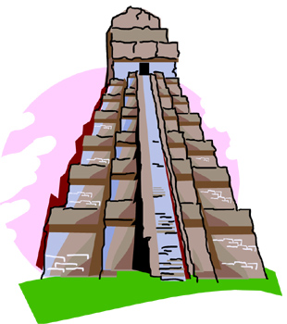 | Mayan Civilization developed in the rainforests of __________ where the Mayas built large cities out of stone. The Mayas were expert __________, building temples, palaces, and even ball courts. In one city alone, the city of _________, the remains of thousands of buildings have been found including six large temples in the shape of __________.
They developed a system of writing using __________ similar to Egyptian hieroglyphics where pictures represented words. They carved these glyphs into stone and or wrote them on __________ made from the bark of fig trees.
The Mayas were also interested in __________. They __________ the stars and planets in the night sky and developed a very accurate __________ that had 365 days.
In mathematics, the Mayas developed a number system that included a symbol for __________. They could write any number using just the symbols for zero, one and five.
The Mayas had a well-developed __________ economy. Lowland cities traded rubber, cotton and cocoa beans (used for making chocolate) for jade and __________ found near highland cities.

