Inca Empire Crossword
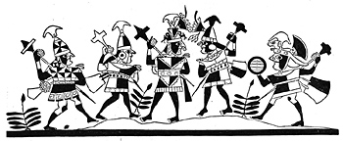

Across
3. Spanish leader who defeated the Incas.
6. Beautiful stone city high in the Andes mountains.
9. Inca ruler captured by Pizarro.
11. A Spanish soldier-explorer who helped conquer the New World.
13. Killing a human or animal for the gods.
15. Tears of the moon.
17. Sweat of the sun.

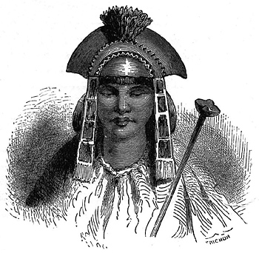

Down  1. A preserved body of a dead person.  2. The sun god.  3. Inca ruler who conquered many lands surrounding Cuzco.  4. The mountain range next to the Inca Empire  5. The ocean next to the Inca Empire.  7. A vegetable that was called the edible stone by the Spanish. | 8. Inca god who created the earth, humans, and animals.  10. Animal found in the Inca Empire that was used for meat and wool.  12. Knotted strings that were used for recording information.  14. The Inca capital city.  16. Something that makes travel from one region to the next easy.

