Inca Civilization
Inca civilization developed in South America from around 1200 to 1533 A.D.
Andes | agriculture |  | cultivated | diversity
Machu Picchu | medicine |  | Pacific | stone
surgery | tomatoes |  | trade | worldwide
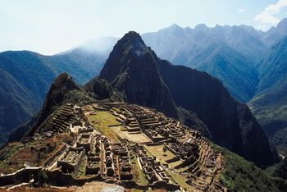  The City of Machu Picchu |  | The Inca empire was located in South America between the ___________ mountains and the ___________ Ocean. Their empire was connected by thousands of kilometers of roads that allowed ___________ to develop between the highlands and the coast.
The Incas were skilled workers of ___________. An excellent example of Inca engineering can still be seen in the stone city of ___________, built high in the Andes Mountains.
Inca __________ was well-developed. They had a great __________ of crops to sustain them. They ___________ around seventy crops including corn, chili peppers, cotton, ___________, peanuts, and potatoes. Many of these crops are now important crops ___________.
The Incas also developed a complex system of ___________. They could treat many infections and even performed skull __________ where they drilled holes in skulls to relieve pressure. | 

