Early Judaism Crossword
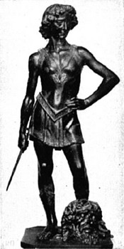
David with Goliath's Head
Across  1. The belief in many gods.  3. The settling of Jewish people in countries outside of Israel.  5. The religion of Jewish people.  8. A place where Jewish people worship.  9. God gave Moses ten of these.  12. The name of a Jewish religious text.  13. The belief in only one god. | Down  2. A mass movement of people.  3. King who defeated goliath.  4. Body of water that Moses crossed.  6. Jewish man who led his family out of Mesopotamia.  7. Wise king of Israel  8. The desert that Moses crossed.  9. The land that God promised Abraham.  10. The place from which Moses and his people fled.  11. A day of rest.

