Early Christianity and Rome Crossword
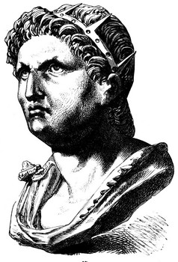
The Emperor Nero accused Christians of setting fire to Rome and began persecuting them in 64 A.D.

Across
2. Emperor who accused Christians of burning Rome and began persecuting them.
6. The twelve people who carried the message of Jesus to the world.
7. Someone who dies for their beliefs.
8. The belief in more than one god.
10. The order that Constantine gave in 313 that gave religious freedom to everyone in the Empire.
11. Short stories that expressed spiritual ideas.
12. What the bishop of Rome became over time.
13. Being killed by being nailed to a cross.
14. Emperor who made Christianity the official religion of Rome.
Down  1. The first Christian emperor.  3. 86-year-old bishop and Christian martyr from Asia Minor.  4. Emperor who began the last great persecution of Christians in the Empire.  5. A person who follows someone else's teachings.  9. The belief in only one god.  11. To punish, mistreat, or harass someone because of their beliefs. | 