The Aztec City of Tenochtitlan
The Aztec city of Tenochtitlan dominated Mesoamerica at the time of contact with Spain.
aqueducts | archeologists |  | causeways | conquest
island | marketplaces |  | Mexico | population
ruins | temples |  | Tenochtitlan | world
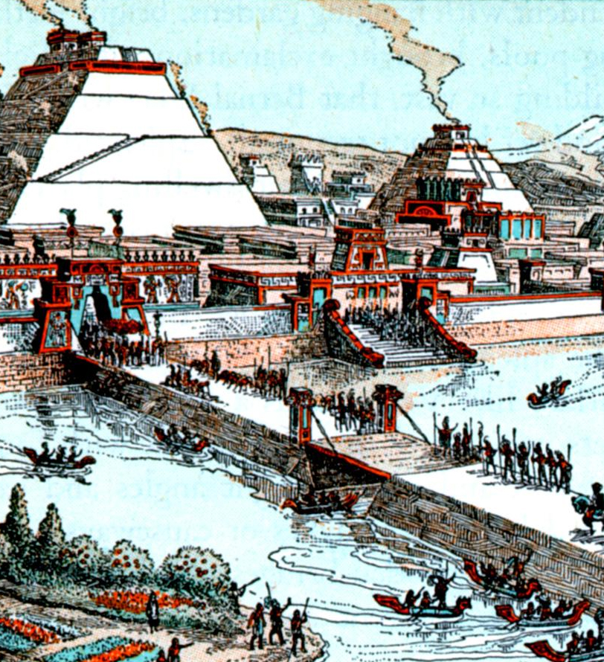  A causeway and bridge leading to Tenochtitlan. |  | The Aztec empire was located in __________. The center of the empire was __________, a city built on an __________ in Lake Texcoco. The city was connected to the mainland by a series of __________ and bridges. At the time of the Spanish __________ it was the largest and most powerful city in Mesoamerica and it was one of the largest cities in the __________. Most estimates put the __________ of Tenochtitlan at over 200, 000 people.
In every district, there were __________ to buy and sell goods. Trade from all over the empire came through Tenochtitlan. There were also __________ that carried freshwater into the city and __________ where the Aztecs worshipped their gods by sacrificing humans to them.
After the Spanish conquest, the city was completely destroyed and a Spanish city, Mexico, was built over the __________. In recent years, __________ have been able to uncover many of the ruins buried under the streets of Mexico. |  |  |  |  | 