Mesopotamia and the First Cities
Cities sprang up in Mesopotamia between 4000 and 3500 B.C. What factors contributed to the growth of cities?
agriculture | building |  | canals | division
Fertile | floods |  | irrigation | silt
surplus | Tigris |  | traders | ziggurats
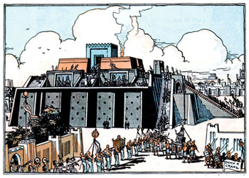  A Sumerian city with  a ziggurat in the center |  | The first cities appeared in Mesopotamia, a region known as the ________ Crescent. Two rivers, the ________ and Euphrates, crossed this region providing water for ________. When the rivers flooded, they left behind ________, which made the soil rich for farming.
In order to use the rivers for agriculture, the Sumerians developed a system of ________ for watering the crops and protecting their settlements from ________. The Sumerians made many ________, ditches, dams, and dykes to control the flow of water.
The success of Sumerian agriculture led to a ________ of food. This meant that fewer people were needed to farm. This led to a ________ of labor since some people could now specialize in other jobs such as crafters, priests and ________. It also meant that more people were available to work on large projects such as ________ city walls or giant pyramid-shaped temples called ________.

