Ancient Mesopotamia Crossword
Across
1. A pyramid-shaped temple.
4. Emperor of Babylon who created a code of laws.
6. Raising crops.
9. A government with a king.
10. ____________ crescent.
11. River that runs through Mesopotamia.
14. A word meaning the land between two rivers.
17. ____________ of laws.
19. Extra of something.
22. A long period without rain.
23. An empire famous for conquering others using iron weapons and war chariots.
24. A person whose job it is to write things down.
26. The empire created by Sargon.

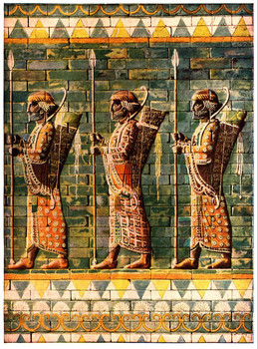
Down  2. An 'epic' king.  3. A writing system using wedge-shaped symbols on a clay tablet.  5. The belief in many gods.  7. A new way of doing things.  8. Place where the first cities arose.  12. River that runs through Mesopotamia.  13. _________ of labor. | 15. Hammurabi's laws were carved on a stone _________.  16. A system of canals, dikes, and dams for bringing water to crops.  17. A country based on one city and the farm lands around it.  18. A word meaning 'city.'  20. Mesopotamia's first emperor.  21. Chief Babylonian god.  25. An ________ for an eye.

