Ancient Mesopotamia Crossword
Across
1. _________ of labor.
4. ____________ of laws.
6. Place where the first cities arose.
8. Hammurabi's laws were carved on a stone _________.
10. Raising crops.
12. A person whose job it is to write things down.
14. An ________ for an eye.
15. A word meaning 'city.'
16. The empire created by Sargon.
19. An event when a river overflows its banks.
23. Emperor of Babylon who created a code of laws.
24. A writing system using wedge-shaped symbols on a clay tablet.
Down  2. A system of canals, dikes, and dams for bringing water to crops.  3. ____________ crescent.  4. A country based on one city and the farm lands around it.  5. The belief in many gods.  7. Chief Babylonian god. | 8. River that runs through Mesopotamia.  9. A pyramid-shaped temple.  11. A word meaning the land between two rivers.  13. River that runs through Mesopotamia.  17. An empire famous for conquering others using iron weapons and war chariots. | 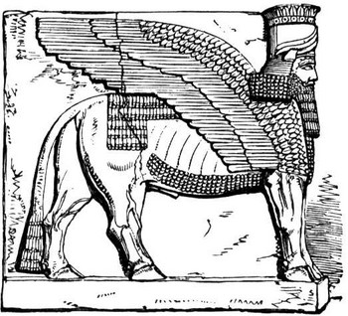
18. A new way of doing things.
20. A long time without rain.
21. A government with a king.
22. Mesopotamia's first emperor.

