Ancient India Crossword
Across
1. A religion founded by Mahavira that emphasized nonviolence.
8. Sacred texts from ancient India.
9. Hindu god with blue skin and four arms.
10. Mountain range to the North of India.
11. God of the sky and war.
12. The ruling warrior caste.
17. The highest caste in Indian society.
19. A prince who founded Buddhism.
20. Warriors who invaded India after the Harappan civilization collapsed.
21. Seasonal wind patterns that wet and dry seasons.
23. A new Hindu empire that came after the Mauryan empire.
24. The philosophy of avoiding violent actions.

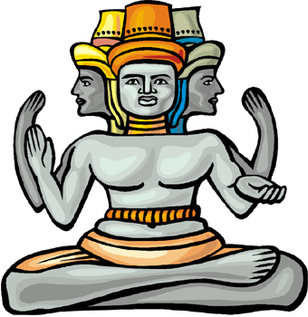
Down  2. Mauryan king who converted to Buddhism  3. The god of destruction.  4. A religion based on the teachings of Buddha.  5. Empire founded by Chandragupta.  6. Early civilization on the Indus river.  7. King who founded the Mauryan dynasty. | 13. The belief that we are born again after we die.  14. Focusing your mind on spiritual things.  15. The largest religion in India today.  16. Not eating.  17. Hindu god of creation.  18. The __________ system. A system that divided people in ancient India into classes.  22. The Indian word meaning caste.

