Sparta's Militaristic Society
Fill in the blanks with words from the box.
children | city-state |  | cliff | courage
dead | deformed |  | exercised | seven
shields | thirty |  | training | war
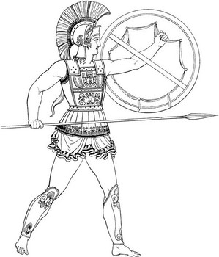 |  | Sparta was a Greek _________ famous for it for its militaristic way of life. Its soldiers were renowned for their skill and _________ in battle. They usually fought with large round _________ and long spears or short swords. They were told to come back victorious or come back _________.
All men had to join the military and their military training began when they were _________. At the age of _________, Spartans boys were taken from their parents and forced into military school. They continued their _________ and remained in the army until they were _________. Even after they were let out of the army they were expected to join the army in times of _________ until they were sixty.
Spartans valued fitness and health. They _________ constantly to maintain strong healthy bodies. If the Spartans thought a baby was puny or _________, they killed the baby by throwing it off a _________.

