Sparta: A Military Society

Sparta was one of the many city-states of ancient Greece. Sparta was a military society and Spartan soldiers were renowned for skill and courage in battle.  Spartan Soldiers  At an early age, Spartan boys were taken from their parents and forced into military school. The boys were not fed well. They were told to steal food, but they were beaten if they were caught. They were not even given beds or shoes to wear. This was to make them tough. |  |  |  | 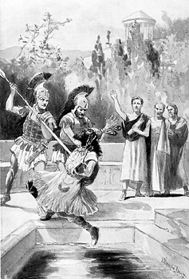  King Leonidas throwing the Persian emissary down a well.
Spartans had to remain soldiers until they were 30 years old. And when their army duty was finished, they had to be in the reserves until they were 60.
Spartans were also required to have perfect bodies. When babies were born, the soldiers would check to see if the babies were healthy. If a baby was not healthy or was deformed in some way, the baby would be taken to the hillside and left to die from exposure, starvation, or wild animals.
Spartans were taught to never flee during a battle. They had to return victorious or dead. They were told before they went into battle to ‘come back with their shields or on their shields’. If they still had their shields that meant they were victorious. In other words, they didn’t drop their shield and run away. If they came back on their shields that meant they were dead and they were being carried home.
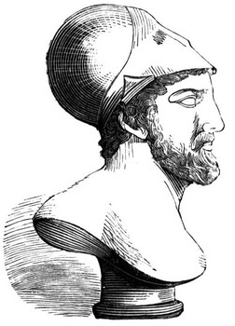 | King Leonidas  King Leonidas is perhaps the most famous of all Spartan rulers. According to legend, he was a descendent of Hercules. He became famous for his stand against the invading Persian army at the battle of Thermopylae.  Persian emissaries under the emperor Xerxes asked all of the Greek city-states to submit to Persia and become part of the Persian empire. The cities of Sparta and Athens refused. In fact, Leonidas is reported to have thrown the emissary down a well.
Angered at the treatment of his emissaries, Xerxes led a massive Persian army to attack Greece. Looking for advice on the upcoming battle, Leonidas went to the Oracle to hear a prophecy. The oracle said that either King Leonidas would perish or else Sparta would be destroyed.
So, knowing he would die, Leonidas set out to confront the Persians in order to prevent his city from being ruined. He chose only men who already had sons to go with him. When his wife, Gorgo, asked what she should do while he was gone, Leonidas told her to marry a good man and have good sons. He knew he would never see her again and he wanted her to be happy.
The Persian Emperor, Xerxes, couldn’t believe that such a small force of Greek soldiers was coming to fight his huge army. Xerxes offered to make Leonidas the King of all Greece if he surrendered. Leonidas replied that it was better to die for Greece than to be the sole ruler of Greece.
After that, Xerxes demanded that the Greeks surrender their weapons. Leonidas told him to ‘come and get them,' meaning that if Xerxes wanted the weapons he would have to fight for them. In the end, Leonidas died bravely and became a Greek hero.
The Battle of Thermopylae  In 480 BC, Xerxes, the Emperor of Persia invaded Greece. 300 Spartans led by King Leonidas and several thousand other Greeks, went north to battle the Persians, who numbered in the hundreds of thousands.  The Persians greatly outnumbered the Greeks. In fact, one Spartan soldier said that there were so many Persian soldiers that their arrows would ‘hide the sun’. Another soldier replied, "That’s good. We’ll fight in the shade." |  |  | 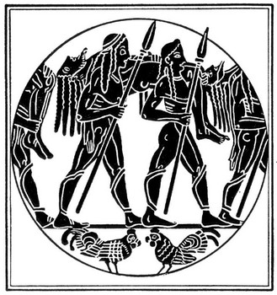
The Battle of Thermopylae shows how a small well-trained army in the right terrain can fight successfully against a very large army. The Spartans waited in a narrow pass, where the Persians were unable to use their vastly superior numbers. Wave after wave of Persians attacked the pass, but they couldn’t break through because the Spartans were much better fighters. Tens of thousands of Persians died and the Spartans had only a few casualties.
On the third day, a Greek traitor showed the Persians a goat trail that went around the pass. The Greeks were forced to retreat. The Spartans didn't retreat with the main Greek force however. They stayed and fought to the last man.
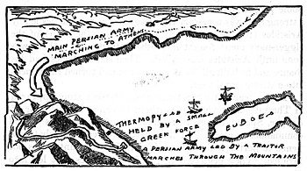 |  | This map shows how the Persians were delayed by the Spartans for three days at the pass of Thermopylae. It also shows the goat trail the Persians used to get around the pass.

Comprehension Questions

Part 1: Spartan Soldiers
(1) What are Spartan soldiers renowned for?
(2) How were the boys toughened up?
(3) What happened to Spartans who were born with deformed bodies?
(4) What could Spartans never do during a battle?
(5) What did it mean if they came back with their shields?
(6) What did it mean if they came back on their shields?

Part 2: King Leonidas
(1) According to tradition, who was King Leonidas a descendent of?
(2) What did the Oracle say?
(3) What did he tell his wife to do?
(4) What did Xerxes offer Leonidas?
(5) What did Xerxes demand from Leonidas and the Greeks?

Part 3: The Battle of Thermopylae
(1) What did one Spartan soldier say the Persian arrows would do?
(2) What did another Spartan reply?
(3) What does the Battle of Thermopylae teach us about war?
(4) Where did the Spartans wait for the Persians?
(5) How did the Persians finally beat the Spartans?

