Sparta in the Classical Age Crossword
Across
4. Greek citizen soldiers that usually used a large round shield and a spear.
7. Battle where 300 Spartans fought a huge Persian army.
8. The wife of king Leonidas.
9. Famous Spartan king.
10. A country that consists of a city plus the surrounding countryside.
13. The age at which Spartan men left the reserves.
14. In Greek myth, he was the king of Sparta and husband of Helen.

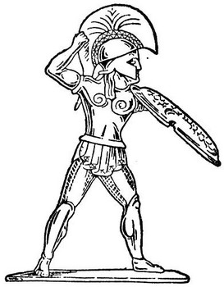
A Greek hoplite
Down  1. In Greek myth, this Spartan woman was taken to Troy by Paris.  2. The age at which Spartan men left the military.  3. A slave owned by the Spartan state.  5. War fought against Athens. | 6. Type of government in Sparta.  9. Spartan general who defeated the Athenians in the Peloponnesian War.  11. The number of kings in Sparta.  12. The age at which Spartan boys started military school.

