Across
3 The god who invented wine making.
6 Messenger of Zeus.
8 Goddess of marriage and childbirth.
9 Mother of Persephone.
10 Twin brother of Artemis.
11 Twin sister of Apollo.
14 Daughter of Demeter.
17 Gaea’s first children.
18 God of the Underworld.
19 God of smiths and fire.
21 Messenger of the gods.
22 Husband of Gaea.
Down  1 King of the gods.  2 God of the sea.  4 The only Olympian who had neither mother or father.  5 Place where Uranus threw the Titans and the Cyclopes.  7 The goddess who helped Hephaestus. | 10 God of war.  12 Mother Earth.  13 Titan who defeated Uranus.  15 Home of the gods.  16 Goddess of wisdom.  18 Goddess of the hearth.  20 God of love. | 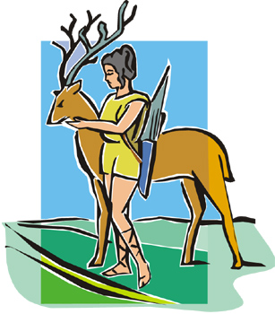

Across: 3 Dionysus, 6 Hermes, 8 Hera, 9 Demeter, 10 Apollo, 11 Artemis, 14 Persephone, 17 Titans, 18 Hades, 19 Hephaestus, 21 Iris, 22 Uranus.

Down: 1 Zeus, 2 Poseidon, 4 Aphrodite, 5 Tartarus, 7 Thetis, 10 Ares, 12 Gaea, 13 Cronus, 15 Olympus, 16 Athena, 18 Hestia, 20 Eros.

