Greek City-States
Ancient Greece was not a country with a single government. Instead, ancient Greece was divided into hundreds of independent city-states (cities that acted like countries). These city-states usually included a city plus its surrounding countryside, farms and small villages. Each city-state had its own government, laws, and customs. | 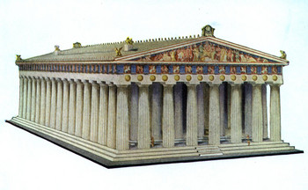

Most ancient Greeks were loyal to their own city-state. If asked where they came from, they would reply, "I am from Sparta," "I am a citizen of Athens," or "I come from Thebes." They would probably not say, "I am from Greece."

Though the Greek city-states were fiercely independent, these city states did have many things in common. They worshipped the same gods, they spoke the same language, and they had the same cultural background. And in times of foreign invasion (such as the Persian wars), they would band together to fight a common foe.

Most of the city-states were monarchies ruled by a king. Some of the city-states were oligarchies ruled by the powerful elite members of society. Athens had a very special kind of government called democracy, which meant 'rule of the people.' In Athenian democracy, people voted for the laws that they wanted.

Comprehension Questions
(1) What kind of countries existed in ancient Greece?

(2) What is a city-state?

(3) How were city-states different from one another?

(4) What did city-states have in common?

(5) When did city-states unite?

(6) What kind of governments existed in the various city-states?

(8) What is a monarchy?

(9) What is an oligarchy?

(7) What special kind of government did Athens have?

Questions to Think About
(1) How do you reply when somebody asks you Where are you from?

(2) Has your country ever been divided into city-states?

(3) What are some advantages of city-states?

(4) What are some disadvantages of city-states?

(5) What kind of government do you think is the best? Why?

Make a table of advantages and disadvantages of each government style.
Government | Monarchy | Oligarchy | Democracy
Advantages
Disadvantages

© 2011 www.littlehistorians.com

