The Greek City-States
Before Greece was conquered by Alexander the Great, the Greece was divided into small countries centered on individual cities.
acropolis |  | agora | arts | city-states
divided |  | government | language | militaristic
oligarchy |  | polis | thinkers | voted
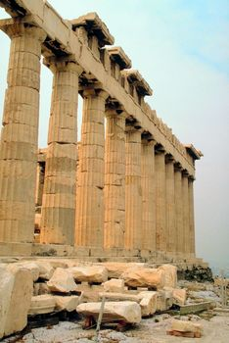 | Though everyone in ancient Greece spoke the same _________ and worshipped the same gods, Greece was not a united country. Instead the Greece was _________ into hundreds of _________, which were small countries that included a city and the surrounding farmland. The Greek word for a city-
state is _________. A typical polis had a marketplace called an _________ and a fortress on a high hill called an _________.
Each city-state had its own form of _________ and system of laws. Athens, for example, is known for its democratic government where all citizens _________ to choose new leaders or make new laws. Sparta, on the other hand, was ruled by an _________, which consisted of two kings and a council of important citizens.
As well, as having different forms of government, Greek city-states could have very different cultures as well. Spartan society was _________. All citizens of Sparta spent a large part of their life in the army. In contrast, Athenians loved the _________. Athens produced many great _________ and writers.

