Democracy in Athens
Fill in the blanks with words from the box.
assembly | city-state |  | debates | democracy
hands | oligarchies |  | participating | people
pottery | vote |  | war | Women
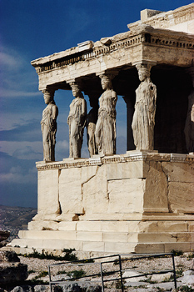 |  | The Greek _________ of Athens was famous for its method of government. Unlike most Greek city-states, which were ruled by _________, monarchies or tyrants, Athens in the 5th century B.C. was a _________, which means the rule of the _________.
In Athens, male citizens would gather in an _________ on a hill and make new laws for the city. At the assembly, every Athenian citizen had the right to speak his opinion. Citizens had public _________ and speeches before laws were passed.
In Athenian democracy each male citizen also had a right to _________. The citizens usually voted by having a show of _________. If they needed a secret vote then they voted by scratching their answers on a broken shard of _________.
The Athenians felt strongly about democracy. Pericles felt that _________ in government was as important as defending the city in times of _________. However, Athenian democracy excluded many people. _________, slaves, freed slaves and foreigners were not given the right to vote.

