Democracy in Athens Crossword
Across
2. A gathering of people.
3. A government by a few powerful elite members of society.
6. This half of the population was not allowed to vote.
7. A person who was not free.
8. Type of democracy where all citizens voted directly on each law.
11. A person who has all of the rights of a country.
12. A public argument about laws or policy.

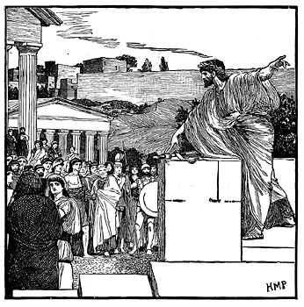

Down  1. A person who rules by force.  2. City-state that is considered to be the birthplace of democracy.  4. The rules of a country and its people.  5. Father of Athenian democracy. | 8. A type of government where all citizens participated in the vote.  9. Secret votes were done by scratching a vote onto a broken piece of ________.  10. Votes were usually down by a show of _________.

