The Arts and Science During the Golden Age
Academy |  | comedies | flourished | Golden
history |  | outdoor | philosophers | Plato
questions |  | Socrates | theaters | tragedies
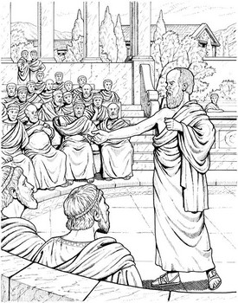 | During the ________ Age of Athens, the arts and sciences ________. Pericles thought that Athens should become the 'school of Greece' so the Athenians built many temples, ________, and other public buildings. Artists, writers, and scientists came from all over Greece to study in Athens.
The Greeks loved to watch plays at ________ theaters. Some writers such as Aristophanes wrote humorous plays called ________. And other writers such as Sophocles wrote serious plays called ________ where the main characters came to an unhappy end. There were numerous other writers as well. Herodotus, who is sometimes called the father of ________, wrote a history of the Persian Wars.
Many great thinkers called ________ lived in Athens during its Golden Age. These philosophers tried to discover the real nature of the world and human beings. The most famous was probably ________ who taught his students by asking ________ instead of just telling them answers. He wanted them to think for themselves. His student ________ went on to build the ________, which became one of the most famous schools in ancient times.

