The Afterlife and the Feather of Truth
Passage into the afterlife, which is described in the Book of the Dead, involved a trial to see if a person had been good or evil in life.
afterlife | Anubis | crocodile | evil
feather | good | heavier | lighter
Osiris | reeds | souls | trial

Ancient Egyptians believed that when they died their __________ could travel to the __________, a place where people lived forever without sickness or death in a field of __________. But not everybody was allowed to enter the afterlife. | 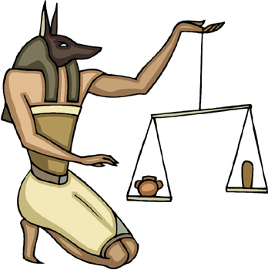
Ancient Egyptians believed that only __________ people could enter the afterlife. So when people died, their souls were put on __________ where __________, the god of the afterlife, judged their deeds in life. Another god, __________ (who had the head of a jackal), weighed the person's heart against the __________ of truth. If the heart was __________ than the feather, that meant the person had been good and was permitted to enter the afterlife.
On the other hand, if the heart was __________ than the feather of truth, that meant the person had committed __________ acts during his or her life. In that case the person was forbidden from entering the afterlife and instead the demon Ammit the bone eater, who had the head of a __________ and the body of a lion and hippo, would eat the person's heart.

