Ancient Egypt Crossword
Across
1. Architect of King Djoser.
5. The type of pyramids that were first built.
7. A reed that can be used for papermaking.
9. A temple in Thebes.
11. God of the afterlife.
13. A time when a river overflows its banks.
14. A guardian with the head of a person and body of a lion.
16. River that runs through Egypt.
18. Fast flowing water with boulders and rapids that make it difficult for boat travel.
19. The process of making a mummy.
21. A person who writes.
22. An Egyptian queen who became pharaoh.
23. A series of rulers from the same family.
24. The preserved body of a dead person.
25. A ruler in ancient Egypt.
26. Land to the south of Egypt.
27. Middle Kingdom pharaoh known as 'the Great.'
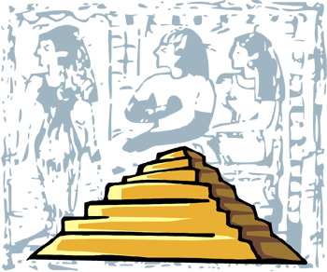
Down  2. Egyptian writing.  3. Triangle-shaped land at the mouth of a river.  4. Pharaoh who built the great pyramid.  6. A giant stone tomb.  8. Jackal-headed god.  10. A tablet that tells of the unification of upper and lower Egypt.  12. The part of Egypt near the Mediterranean. | 13. __________ of truth.  15. A pharaoh who died young leaving a tomb full of gold to be found by modern archeologists.  17. The part of Egypt near Nubia.  20. Goddess whose tears caused the Nile floods in Egyptian beliefs.  22. People who conquered Egypt at the end of the Middle Kingdom.  23. Book of the ___________.

