Ancient Egypt Crossword
Across
2. A time when a river overflows its banks.
4. __________ of truth.
6. Land to the south of Egypt.
9. Triangle-shaped land at the mouth of a river.
10. The part of Egypt near Nubia.
11. Middle Kingdom pharaoh known as 'the Great.'
12. A reed that can be used for papermaking.
15. Fast flowing water with boulders and rapids that make it difficult for boat travel.
16. Pharaoh who built the great pyramid.
17. A giant stone tomb.
20. Architect of King Djoser.
22. The process of making a mummy.
23. Goddess whose tears caused the Nile floods in Egyptian beliefs.
24. People who conquered Egypt at the end of the Middle Kingdom.
26. Egyptian writing.
27. A pharaoh who died young leaving a tomb full of gold to be found by modern archeologists.
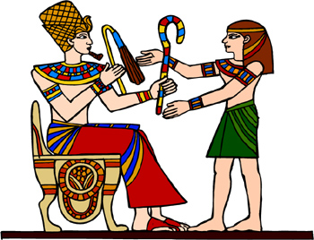
Down  1. A person who writes.  3. Book of the ___________.  5. An Egyptian queen who became pharaoh.  6. River that runs through Egypt.  7. A tablet that tells of the unification of upper and lower Egypt.  8. Jackal-headed god. | 13. A ruler in ancient Egypt.  14. The type of pyramids that were first built.  16. A temple in Thebes.  18. The preserved body of a dead person.  19. A series of rulers from the same family.  21. God of the afterlife.  25. A guardian with the head of a person and body of a lion.

