The Silk Road
The Silk Road was a trade route from China to Europe. How did it aid in the diffusion of ideas and goods?
Buddhism | caravans |  | demand | deserts
diffusion | exported |  | light | luxury
risk | silk |  | Silk Road | spices
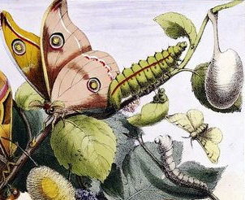  A silk worm |  | One of the most important products that ancient China ________ to the world was ________, a light and soft fabric made from the cocoons of silk worms. There was a high ________ for silk from places as far away as Rome. Though the journey was long and perilous, the high prices of silk in foreign countries made it worth the ________.
Silk and other goods traveled from China through vast ________ and over mountain ranges. The route that many of these traders took became known as the ________ because silk was the most important good that was traded along it.
In order to protect themselves, merchants often traveled in groups called ________. Because the journey was so long and arduous, most of the goods that were traded along the Silk Road were ________ items that were _______ but expensive such as silk, ivory, _______, fur, and jade.
The Silk Road was also important for the _______ of ideas. For example, traders traveling along the Silk Road brought the religion of ________ into China where it became popular among the rich and the poor.

