Oracles Bones from the Shang Dynasty
The Shang Dynasty ruled a broad of area of Northern China and was especially important for the development of the Chinese writing system.
chariots |  | cities | cracked | innovations
hieroglyphics |  | ideas | oracle | pictographs
prediction |  | Shang | shells | writing
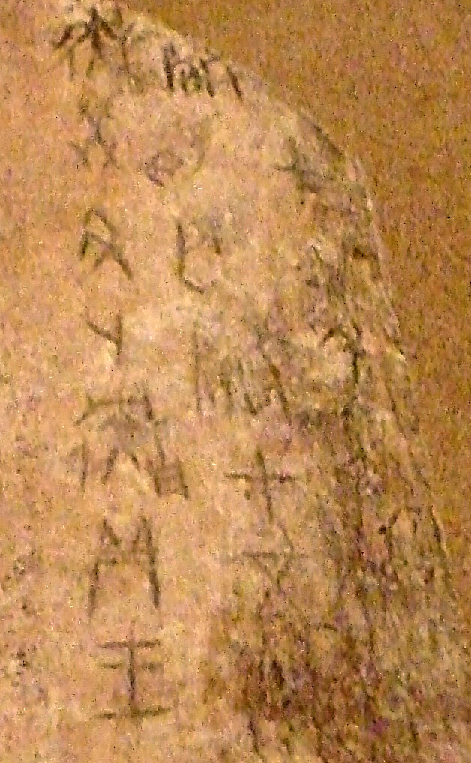 | There were many important technological __________ in China during the ___________ dynasty. Bronze tools, bronze containers, and war ___________ have all been found in the tombs of Shang royalty. People in China may have also begun living in ___________ during this dynasty. But of all these innovations, the most important was the development of a system of ___________.
The writing system used in the Shang dynasty was a collection of __________ similar to Egyptian ___________ where a picture was used to represent a word. The people of the Shang dynasty used more than 2000 of the pictographs to express complex ___________ in writing.
Much of what modern archeologists know of these pictographs comes from __________ bones. Oracle bones are pictographs written on the animal bones and turtle __________. An oracle is a __________ of the future. Shang priests would write questions on the bones using pictographs and then heated the bones until they __________. The priest believed they could read the answers in the way the bones cracked.

