Innovations During the Han Dynasty
What were some of the Han dynasty's contributions to the world?
civil |  | class | Confucius | dynasties
exam |  | history | innovations | paper
poets |  | seismograph | shadows | sundial
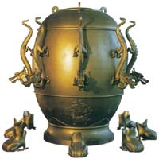  Han Dynasty Seismograph | During the 400 years of the Han dynasty there were many important technological __________. In science, Chinese invented a _________, a machine for telling people when an earthquake struck. Another invention developed during the Han dynasty was the __________, a clock that told time by using __________ cast by the sun.
Perhaps, the most important innovation during the Han dynasty was __________. As papermaking spread, the art and writing also developed. __________ began making new styles of poems. As well, the first __________ of China was written by Sima Qian. He wrote about all of the __________ that came before the Han dynasty.
In government, the emperor Wu Di set up the first __________ service, a group of people whose job it is to run the day-to-day business of the government. In order to become part of the civil service, a government __________ system was created based on the teachings of __________. Anybody from any __________ could take these tests, but often it was the wealthy people who ended up with the government jobs.

