The Cruel Emperor Qin Shi Huang
Shi Huangdi united much of China under the Qin Empire around 221 B.C.
burnt |  | currency | evil | Great Wall
legalism |  | punishments | Qin | region
scholars |  | Shi Huangdi | unify | warriors
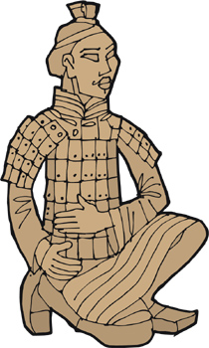 | After the Warring States period, China once again became united under the _________ dynasty. The emperor who finally brought most of China under Qin rule called himself _________, which means first emperor.
Shi Huangdi (also called Qin Shi Huang) followed the Chinese philosophy of _________. In this philosophy, people were regarded as ________ and needed to be controlled by strong laws and harsh _________. Shi Huangdi ordered all books that disagreed with legalism to be _________. When _________ opposed the book burning, he had 460 of them buried alive.
Shi Huangdi did much to _________ the people of China. He forced them to use the same set of characters for writing and use the same _________ for buying and selling goods. He also made laws and punishments the same everywhere in China. Before Shi Huangdi each _________ had its own laws, currency and writing system.
Shi Huangdi forced his people to work on great construction projects such as the _________ where many of the workers died. He also had a tomb built for himself and had it filled with thousands of terra-cotta _________.

