Ancient China Crossword
Across
5. ______________ States Period: A time when China was divided into many small countries that fought each other.
7. Mandate of ___________: the right to rule the people.
8. The philosophy of Confucius.
10. The first emperor of the Han dynasty.
12. First emperor of the Qin dynasty.
13. Important Chinese innovation for writing and bookmaking.
14. ___________ bones were used to make prophecies in the Shang dynasty.
16. Warriors found in Shi Huangdi's tomb.
17. Long fortification that protected northern China.
19. Philosophy based on the teachings of Laozi.
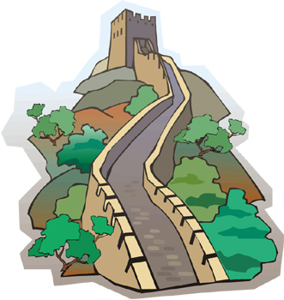

18. Emperor who made the civil service exam system.
Down  1. Chinese philosophy that claimed people where evil and needed to be controlled by strong laws.  2. Very influential teacher who believed people should have a sense of duty.  3. Material that vessels (containers) were made from in the Shang dynasty.  4. A general who explored western China for the emperor Wudi. | 6. A machine that tells when an earthquake happens.  9. Very light, soft and valuable fabric.  11. A system of Chinese medicine that uses needles placed under the skin.  12. An important trade route that went as far as Rome  13. Filial ___________: Respect for parents and elders.  15. ____________ service: A group of government officials.

