Labeling a Spanish Galleon
During the Age of Exploration, Europeans developed many new kinds of ocean going vessels that allowed them to explore and map the world. One type of vessel was the galleon, which the Spanish used to move soldiers, settlers, and treasure throughout their trans-Atlantic empire. | 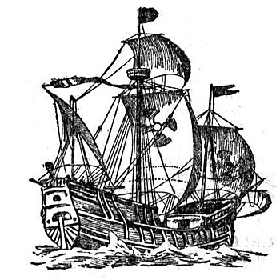

Reading Comprehension Activity

Read the description of a galleon below and label the parts of the galleon in bold on the next page.

Galleons have tall poles that hold the sails. These poles are called masts. The large mast in the center of the ship is called the mainmast. The mast at the front of the ship is called the foremast. The mast at the rear of the ship is called the mizzenmast. There are also three decks where sailors can walk around on the ship. The deck in the center is called the main deck. The deck at the front of the ship is called the forecastle. The deck at the back of the ship is called the quarter deck. Halfway up the mainmast, there is a platform where sailors can stand and watch for other ships or for land. This platform is called the crow’s nest. To get to the crow’s nest, you need to climb some ropes that are attached to the masts. These ropes are called the shrouds. There is another pole that sticks out of the front of the ship. This pole is called the bowsprit. At the back of the ship below the quarterdeck, there is a place where the captain sleeps. This is the captain’s quarters. The place where the crew sleeps is called the crew’s quarters. They are under the forecastle at the bow of the ship. At the back of the ship near the waterline, there is a piece of wood that is used to steer the ship. This piece of wood is called the rudder. Below the decks, there is an area where sailors store food, cannons, and other goods. This area is called the hold. The bottom part of the boat, the part that floats on water, is called the hull.

© 2012 www.littlehistorians.com

Label the Galleon

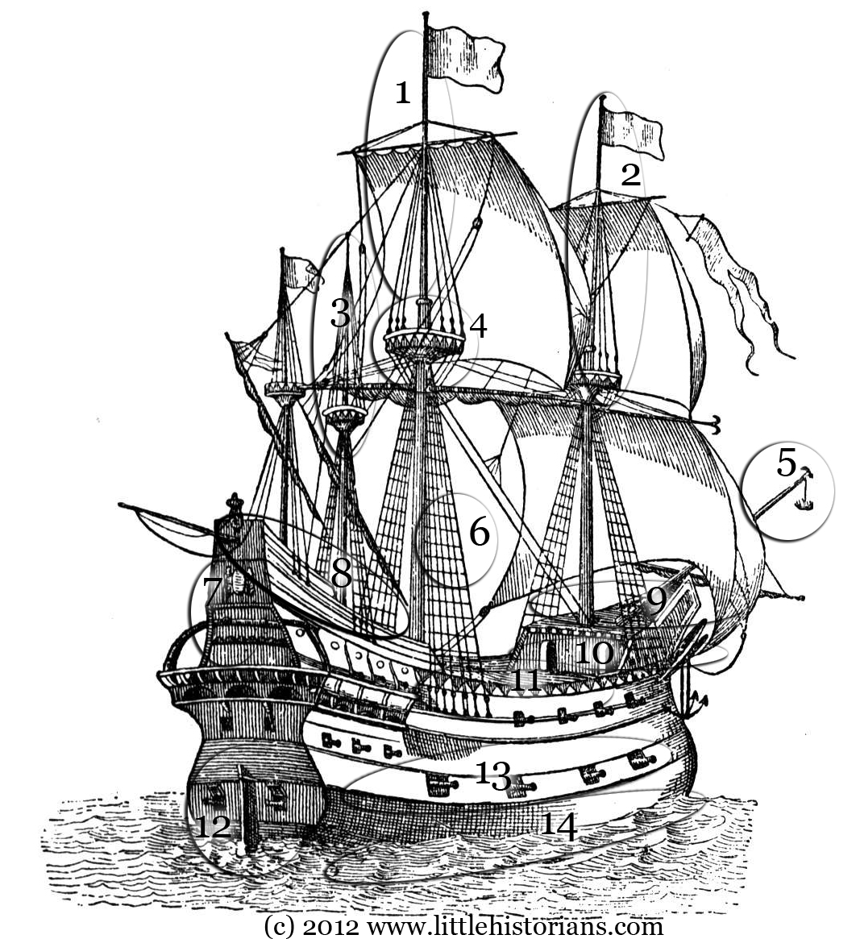
(1) |  | (8)
(2) |  | (9)
(3) |  | (10)
(4) |  | (11)
(5) |  | (12)
(6) |  | (13)
(7) |  | (14)

© 2012 www.littlehistorians.com

