The Age of Discovery:  Famous Explorers  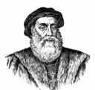  Vasco da Gama  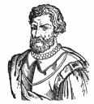  Ferdinand Magellan  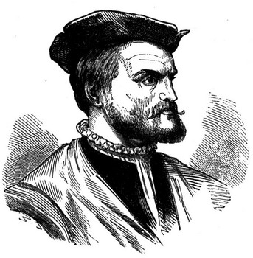  Jacques Cartier | 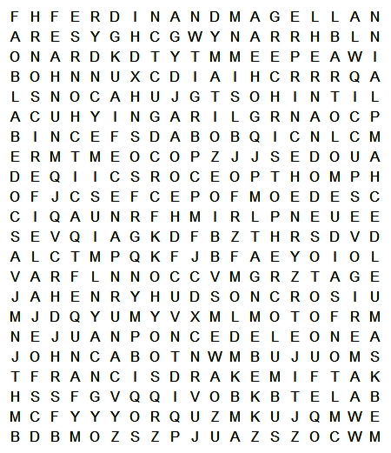
Amerigo Vespucci  Bartolomeu Dias  Christopher Columbus  Ferdinand Magellan  Francis Drake  Francisco Pizarro  Vasco de Balboa |  | Henry Hudson  Hernando Cortez  Hernando de Soto  Jacques Cartier  John Cabot  Juan Ponce de Leon | Leif Ericson  Marco Polo  Martin Frobisher  Prince Henry  Samuel de Champlain  Vasco da Gama

