The Age of Exploration

Across
4 English explorer who circumnavigated the globe. (5)
6 Spanish explorer who explored the American Southwest searching for lost cities of gold. (8)
8 Spanish explorer who conquered the Incas. (7)
9 Viking explorer who may have been the first European to reach the Americas. (7)
10 A ship with a rounded hull and triangular sails that helped Europeans explore the globe. (7)
14 Spanish explorer who explored Florida looking for the Fountain of Youth. (5,2,4)
18 English explorer who explored the Arctic looking for a northwest passage to the Orient. (9)
Down  1 English explorer who explored the Hudson River and Hudson Bay. (6)  2 Portuguese explorer who reached India by going around Africa. (2,4)  3 Spanish explorer who reached the Mississippi River. (2,4)  5 Explorer who crossed Panama and viewed the Pacific Ocean. (6)  6 French explorer who reached the St. Lawrence River. (7)  7 Portuguese explorer who commanded the first voyage to circumnavigate the globe. (8)  10 Italian explorer who explored the Canadian coastline for the English while looking for a northwest passage to the Orient. (5) | 11 Italian explorer who sailed for both Spain and Portugal and who determined that the New World was not part of Asia. His first name is given to the continents North and South America. (8)  12 Italian explorer who first explored the New World for Spain. (8)  13 Portuguese ruler who sponsored many voyages of exploration along the coast of Africa. (5)  15 Spanish explorer who conquered the Aztecs. (6)  16 Portuguese explorer who rounded the Cape of Good Hope (the southern tip of Africa). (4)  17 Italian explorer who travelled overland to China. His book inspired many people to explore. (4) |  |  | 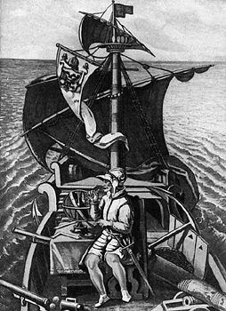  Magellan: His voyage was the first to circumnavigate the globe, though he died before the voyage reached its conclusion.

