Age of Exploration Cloze
Africa | Americas |  | caravel | Discovery
Exploration | gold |  | lateen | lucrative
profits | spice |  | trade | wind
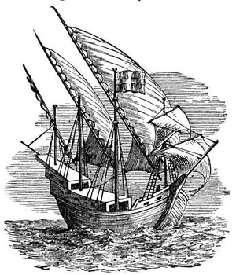  A caravel |  | Beginning in the 15th century, Europeans began exploring the globe in what had become known as the Age of __________ or the Age of __________. One important cause for this burst of exploration was the desire to find alternative __________ routes to India and China.
European explorers wanted to bypass Italian, Turkish, and Arab traders who had a monopoly on the __________ trade. This spice trade was highly __________, earning huge __________ for successful traders. Pepper, for example, was worth its weight in __________. Portuguese and Spanish explorers were among the first to venture out into the Atlantic Ocean in search of direct trade routes to Asia. The Portuguese sailors explored the coast of __________ hoping to circumnavigate that continent and find a direct route to India. Spanish explorers on the other hand sailed across the Atlantic Ocean until they eventually stumbled upon the __________.
One great technological innovation that aided European explorers was the __________, which was a type of ship with triangular sails called __________ sails. This kind of ship allowed European sailors to sail into the __________.

